EXECUTION OF TEST CASES FOR MYE -6

TEST CASE: This test is to validate look and feel of the web elements in the home page.

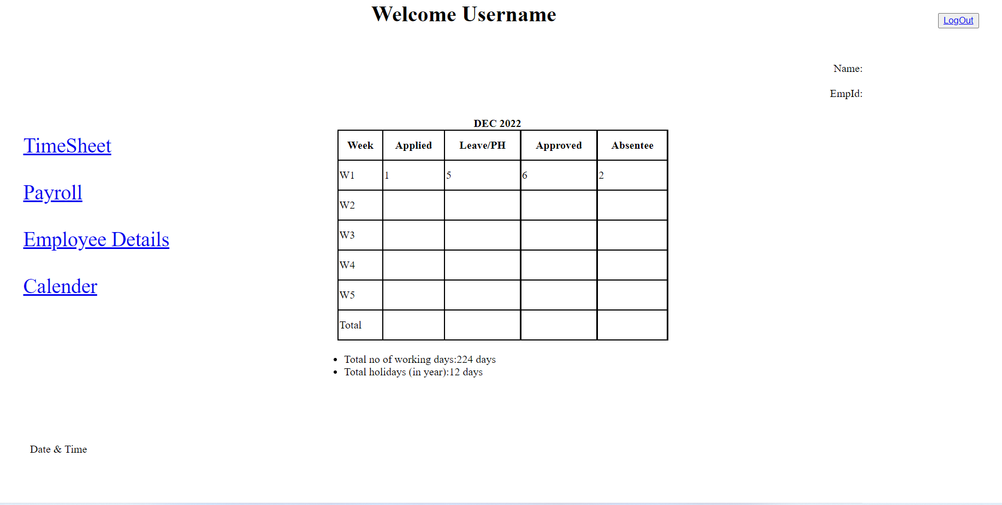

TEST CASE: This test is to validate header in the home page.

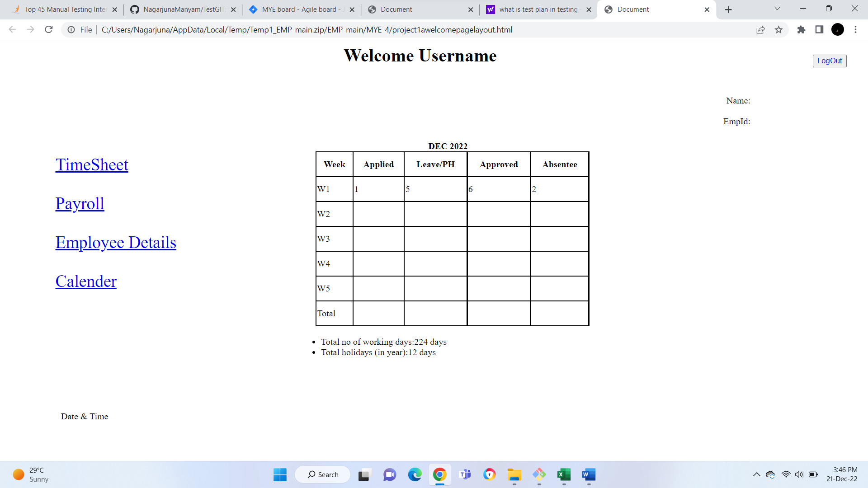

TEST CASE: This test is to validate leave tracker at the center of the home page.

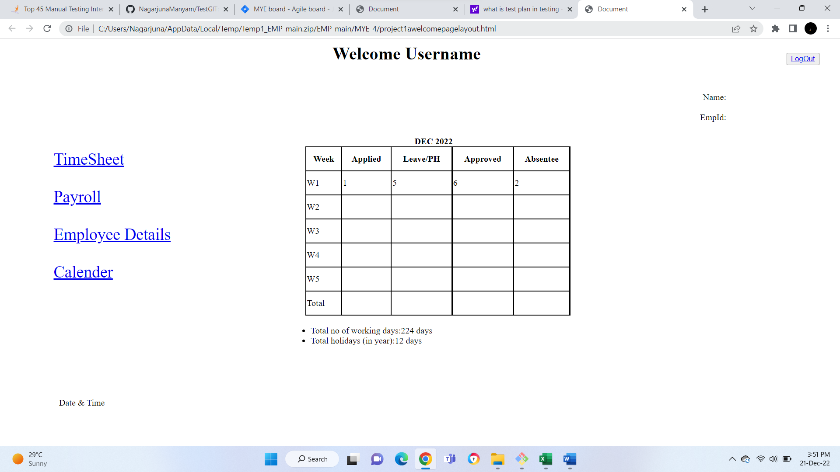

TEST CASE: This test is to validate date and time stamp in the left side bottom corner of the home page

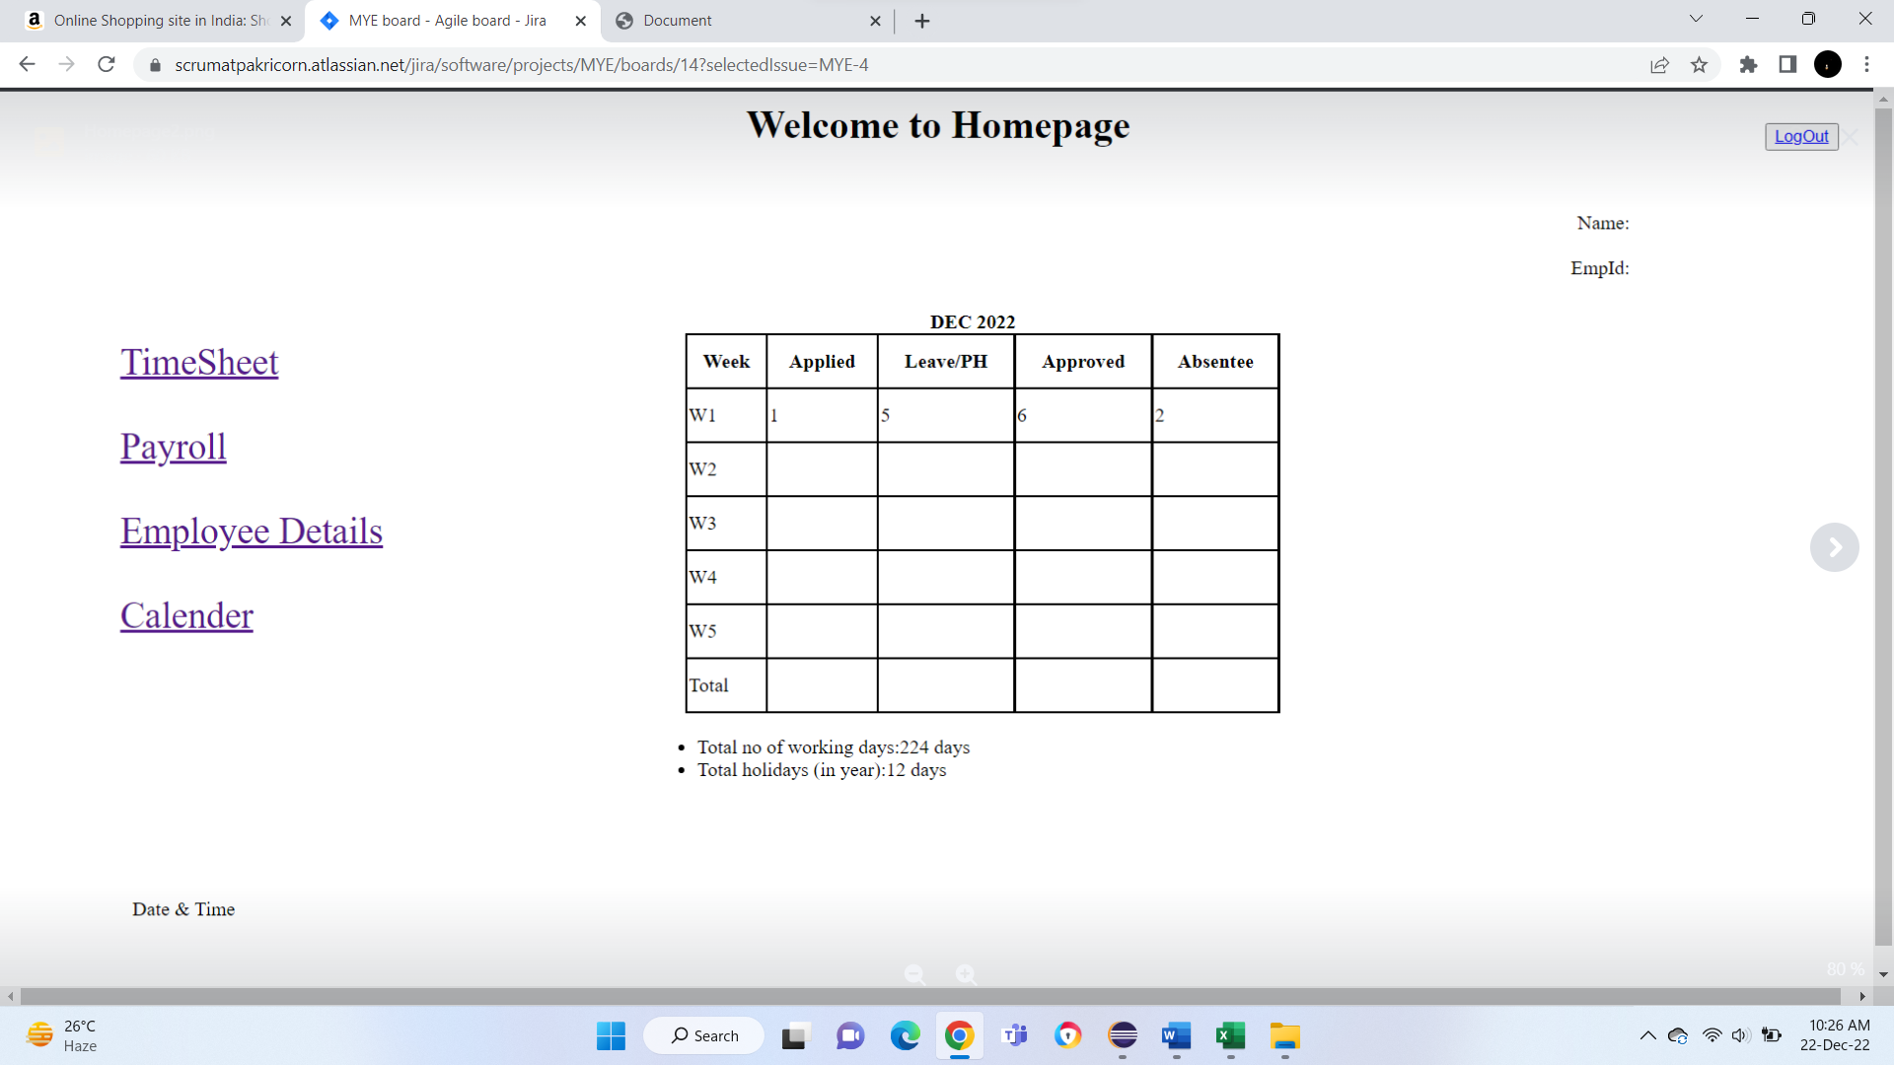

TEST CASE: This test is to validate user is provided with logout button to exit

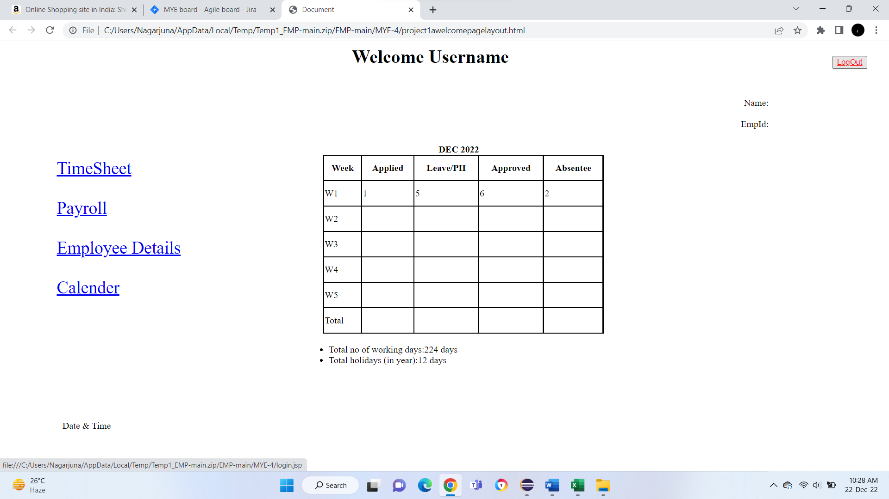

TEST CASE: This test is to validate the user is able to view timesheet Tabs in the left side of the home page.

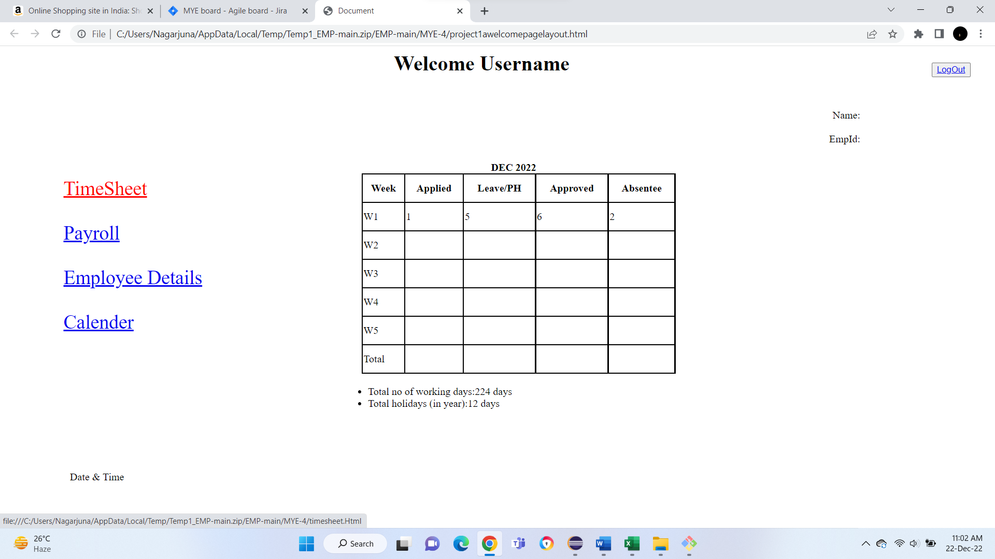

TEST CASE: This test is to validate the user is able to view Payroll Tabs in the left side of the home page.

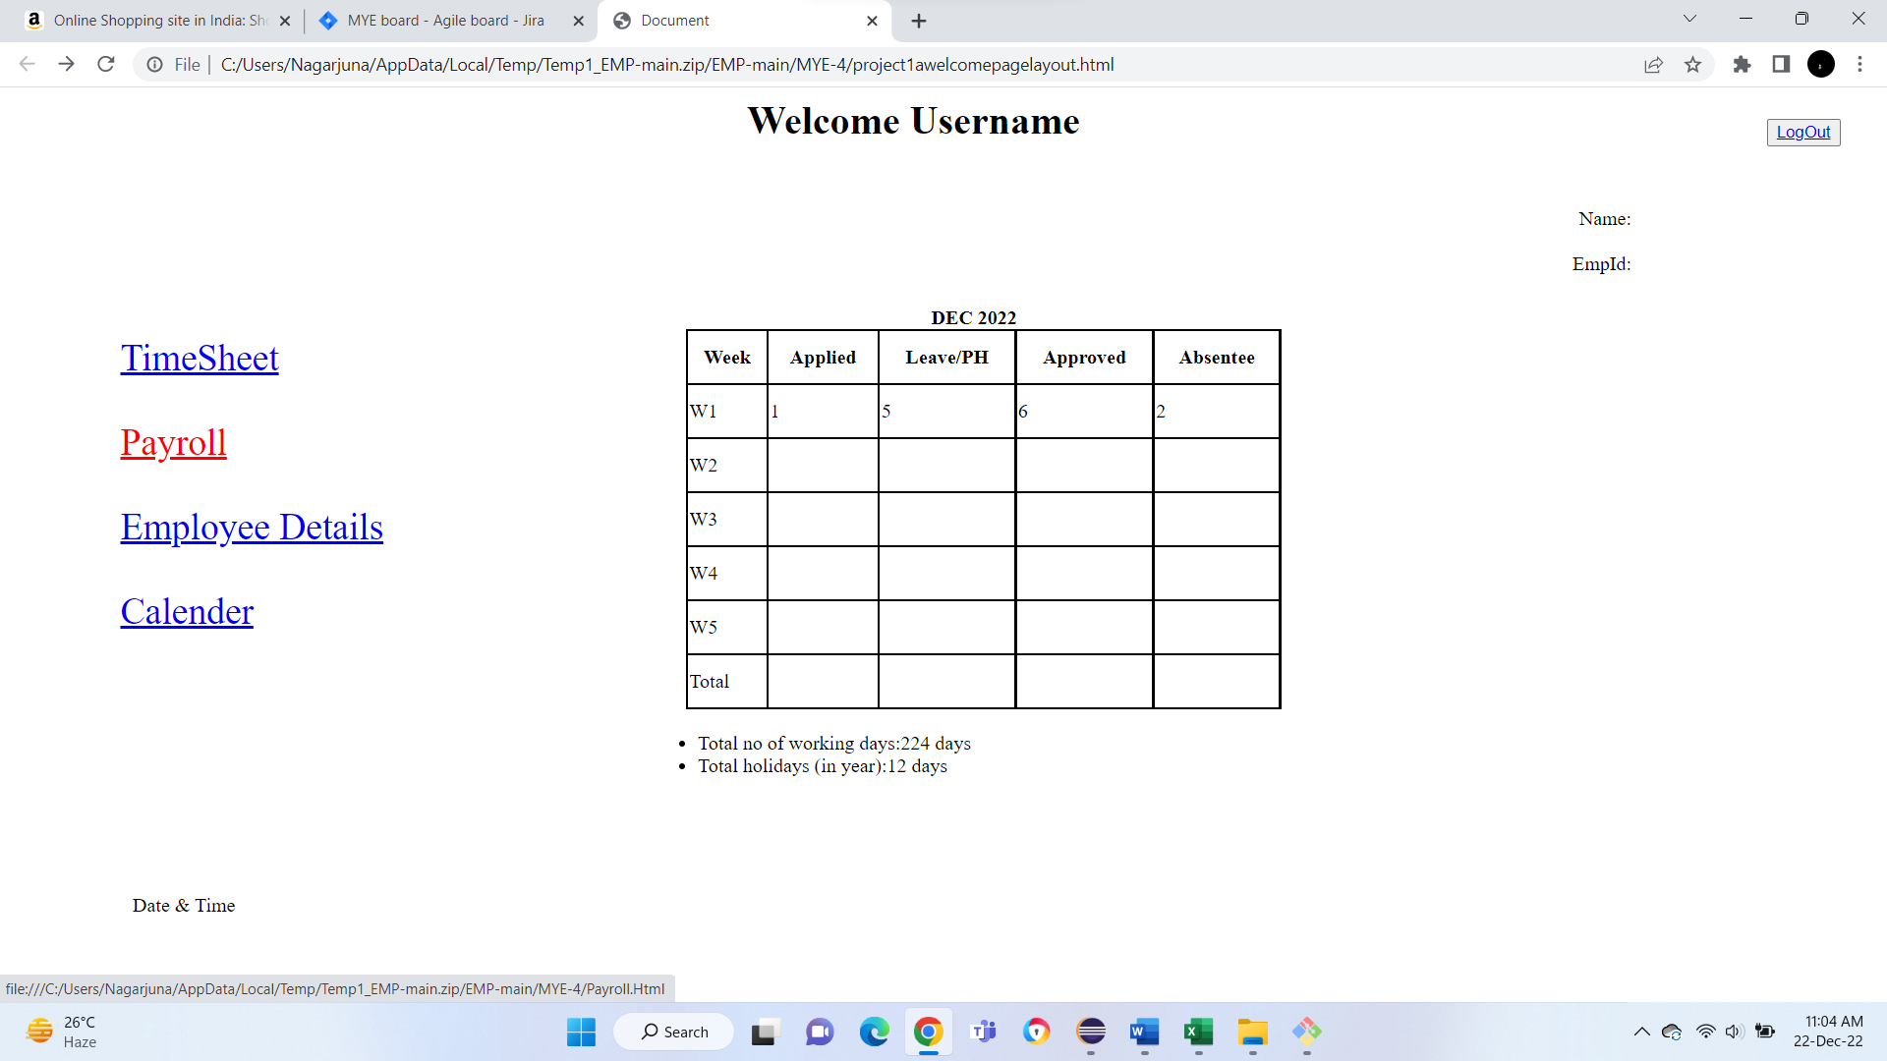

TEST CASE: This test is to validate the user is able to view Employee Details Tabs in the left side of the home page.

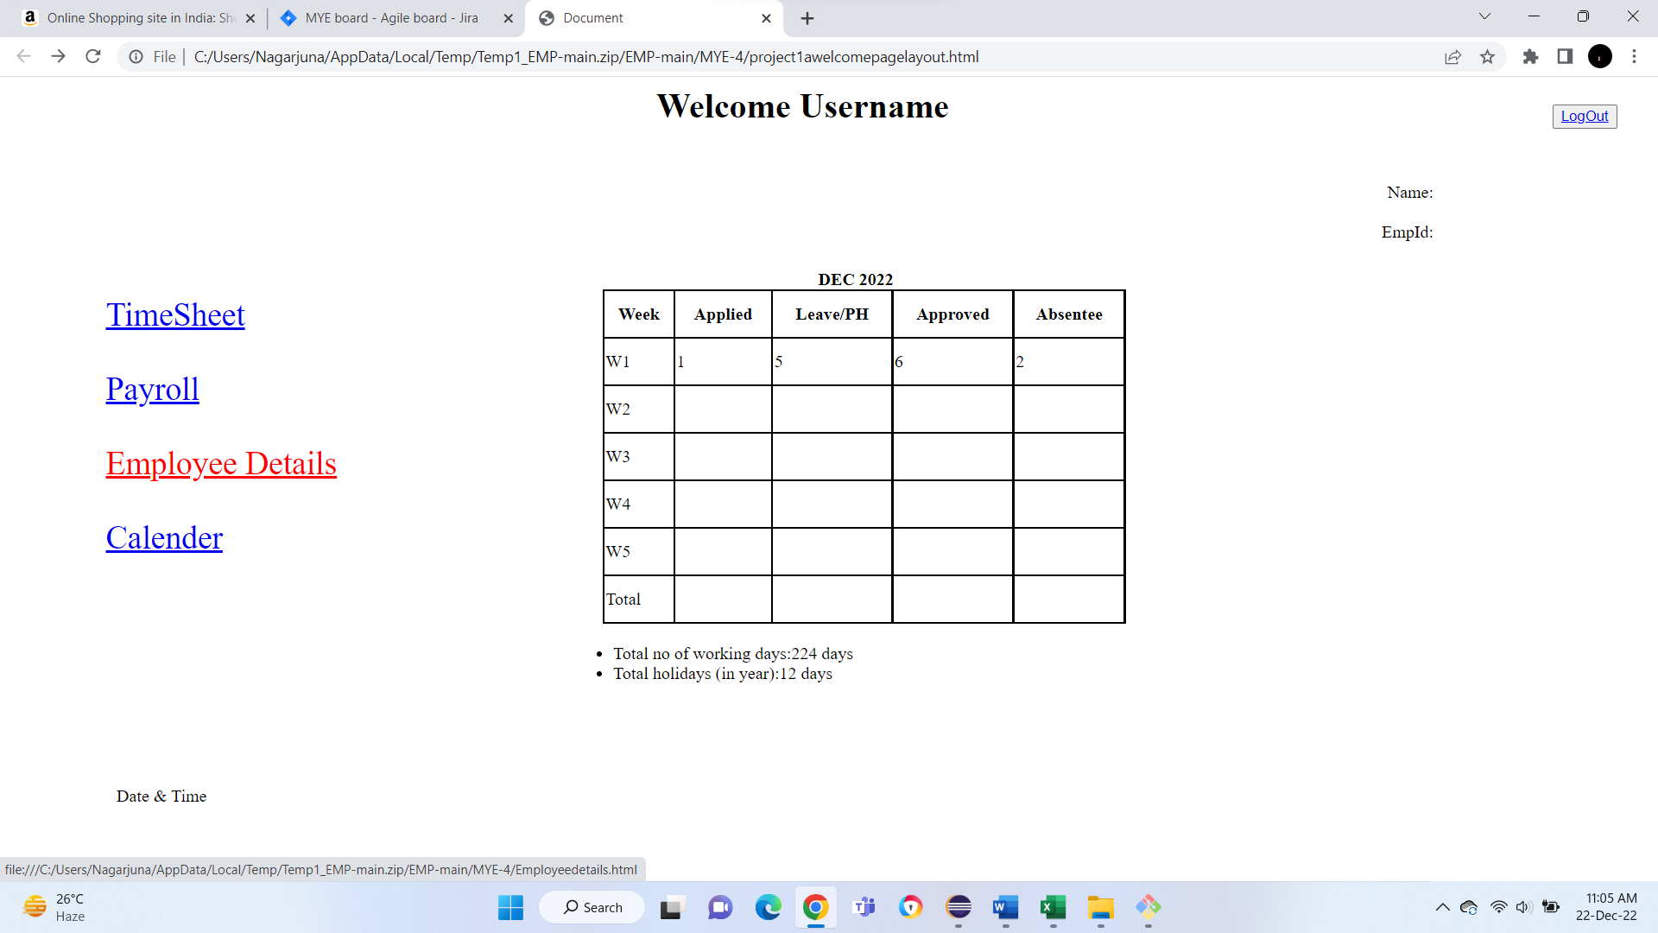

TEST CASE: This test is to validate the user is able to view calender Tabs in the left side of the home page.

